Math 4 Honors Name __________________________

U5 Test Review: Counting Methods & Induction Date _________________________

*Please show your work on another piece of paper.*

Prove the following statements using mathematical induction.

1. 

2. 

3. 

Answer the following questions.

4. Write the first five terms of the sequence defined by:



Write the explicit rule for the sequence.

What is the name of this sequence?

5. Consider the sequence defined explicitly by: 

1. Write the first five terms of this sequence.
2. Classify the sequence as arithmetic, geometric, or neither.
3. Derive a recursive formula for this sequence.

6. Write the following sum using summation notation.



7. Evaluate  OVER 🡪

8. Find the first five terms of the sequence defined explicitly by .



Classify the sequence as arithmetic, geometric, or neither.

9. An arithmetic sequence has a 4th term of 20 and a constant difference of -2.5. Find the 48th term.

10. Blackjack or 21 is a popular card game. A blackjack consists of two cards, one of which is an ace and the other a ten, jack, queen, or king.

1. If the dealer is using a single standard 52-card deck (with 4 different suits and 13cards per suit),

how many different blackjack hands are possible?

b. Two cards are dealt at random from a 52-card deck. What is the probability of getting blackjack?

11. There are 16 athletes entered in the 100-yard freestyle. The pool has only eight lanes so the athletes need to be divided into two groups of eight for the preliminary heats.

1. How many different ways can the athletes be divided into two groups of eight? Show your work

or explain your reasoning.

1. Rachel & Stephanie train together and would like to be in the same group. If the groups are randomly selected, what is the probability that Rachel & Stephanie are in the same group? Show your work or explain your reasoning.
2. Once the groups have been decided upon, the swimmers must be assigned to lanes. In how many

ways can a group of eight swimmers be assigned to the eight lanes of the pool? Show your work or explain your reasoning.

12. Find the 14th term in the expansion of (*a* - 2*b*)17.

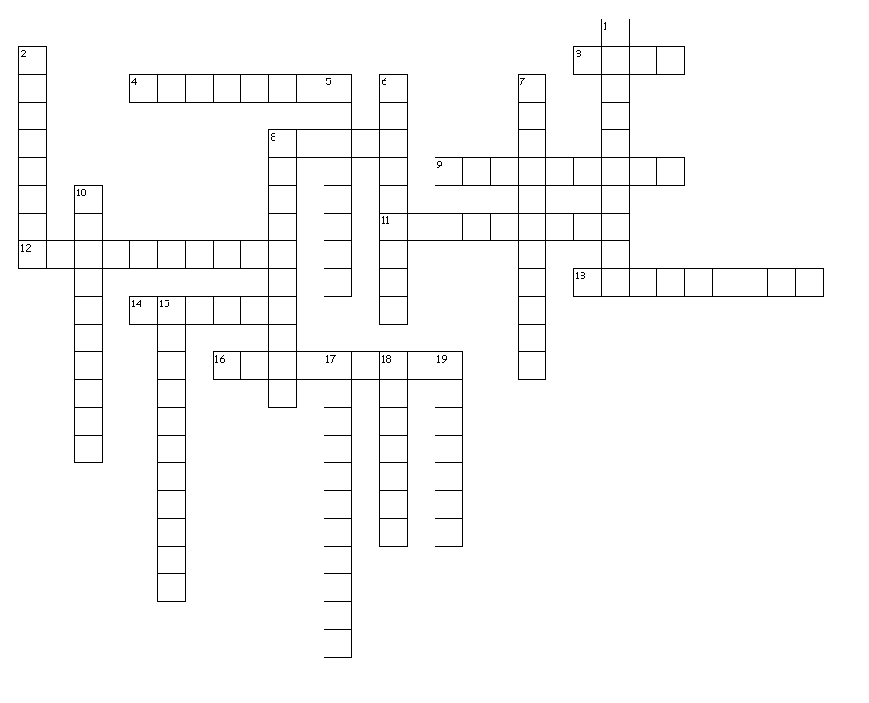**Unit 5 Vocabulary**

**Across**

3. When using the formulas for combinations & permutations, *n* cannot be ______ than *k*.

4. Pascal’s triangle helps in the expansion of ______ expressions raised to a power.

8. Summation notation is also known as ______ notation.

9. A sequence that has a common ratio between consecutive terms is ______.

11. The process of mathematical ______ is used for proving numerical patterns.

12. The sequence 1, 3, 6, 10, 15,… are the ______ numbers.

13. A rule for a sequence that contains two statements is ______.

14. An explicit rule for a sequence allows ______ computation of any term.

16. Order does not matter; repetitions OK

**Down**

1. The ______ relation defines each subsequent term in the sequence by the previous term.

2. A rule for a sequence that contains one statement is ______.

5. Taking medications as prescribed is an example of a ______ model.

6. When using the Multiplication Rule in probability, you multiply separate ______.

7. Order matters; no repetitions

8. When using the Multiplication Principle of counting, you calculate the numerator and denominator ______ to form the ratio.

10. A sequence that has a common difference between consecutive terms is ______.

15. The Multiplication Rule in probability applies to ______ events.

17. Order does not matter; no repetitions



18. The notation means to round up to the nearest ______.

19. The domain of a sequence is the set of ______ numbers.